Goto WMS > Administration > Invenotory Discrepancies
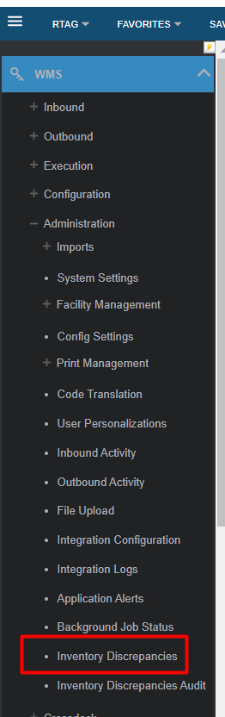
Click “FIND DISCREPANCIES”
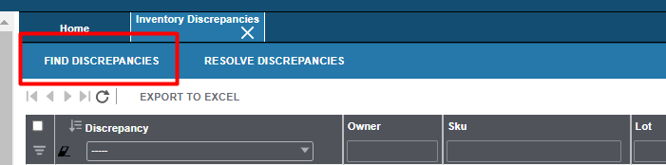
Filter the item in SKU column
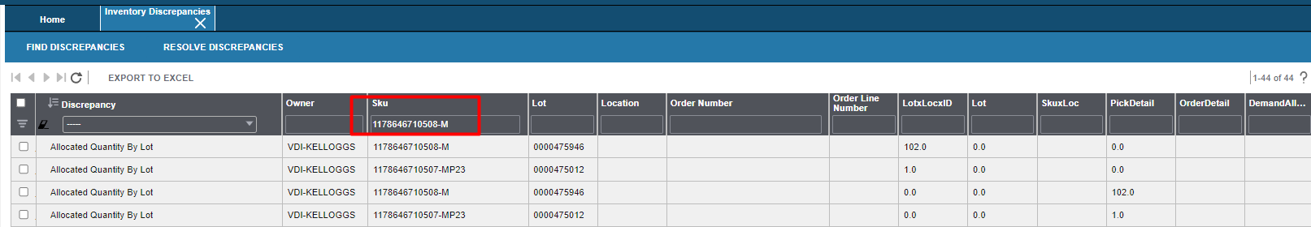

Check the icon box for the selected line items w/ discrepancy then click “RESOLVE DISCREPANCIES”
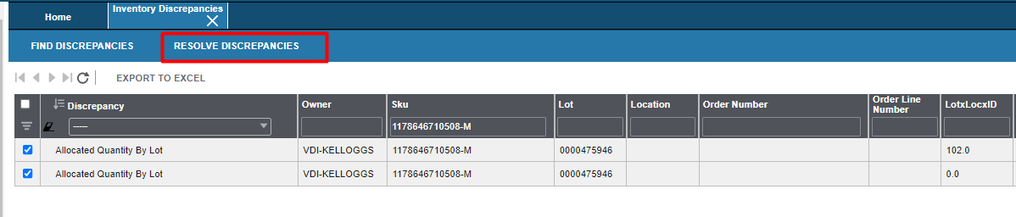

Afte we resolved try again to shipped the orders

